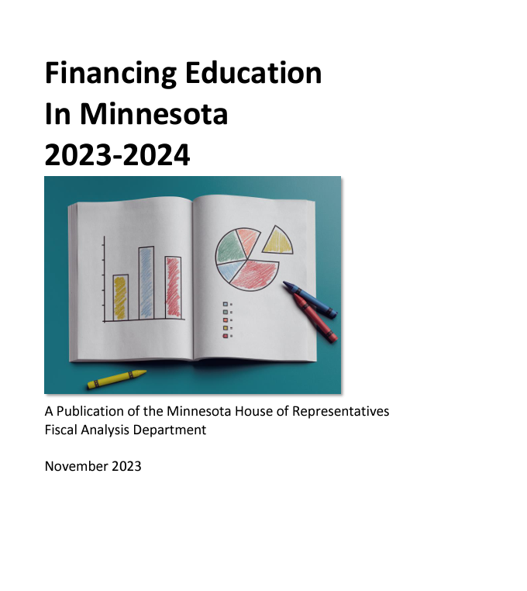

([240555.pdf (mn.gov)](https://www.lrl.mn.gov/docs/2024/other/240555.pdf))

